1. Write a java code with the class named ‘acad’ and a method ‘main’. Hard Code the program with two integers and print the sum of those two.

Source Code: -

class Acad {        //class acad created

public void main(int num1, int num2) {      //method main created and passed two values to it

int sum = num1 + num2; //declaration of variable sum to integer and performing addition

System.out.println("The sum is: " +sum);     //printing the sum of two numbers

}

}

public class Sum { //main class of the program

public static void main(String[] args) {      //main method of the program

int num1 = 10, num2 = 20; //declaration of variables and assigning the values to it

Acad a = new Acad(); //creating object of class acad

a.main(num1, num2); //calling the method main using the object of acad

}

}

Output

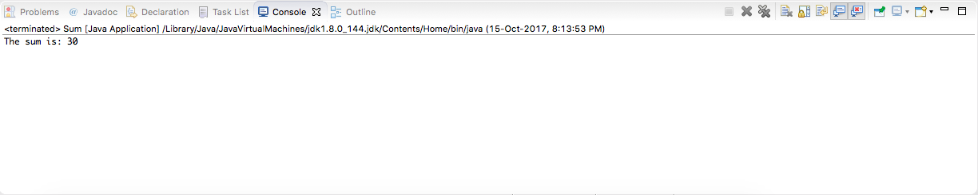

1. Rewrite the above code, where, inputs are provided by the user at runtime and the output is

Source Code: -

package pig2;      //package created named pig2

import java.util.\*; //importing the java.util for accessing the scanner method

class Acad { //creation of class acad

public void main(int num1, int num2) { //creation of method named main and passing two values to it

int sum = num1 + num2; //declaration of variables sum and adding the num and storing it in

System.out.println("The sum is: " +sum); //printing the output on console

}

}

public class Sum { //creation of main class Sum

public static void main(String[] args) { //main method of the program

int num1, num2; //declaration of variables

Acad a = new Acad(); //creation of object of class acad

Scanner sc = new Scanner(System.in); //creation of object of scanner class

System.out.println("Enter 1st number: "); //printing the statement on console

num1 = sc.nextInt(); //taking input from user and storingit in variable

System.out.println("Enter 2nd number: "); //printing the statement on console

num2 = sc.nextInt(); //taking input from user and storingit in variable

a.main(num1, num2); //calling of the main method using the object of class acad

sc.close(); //closing the scanner class

}

}

Output: -

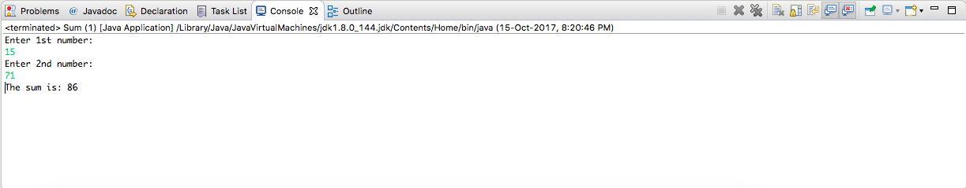

1. Write a program with method name sum() that accepts two parameters from user and print the sum of two numbers. Output format should be as:

First number is:

Second number is:

Sum is:

Source Code: -

package pig3; //creation of package

import java.util.\*; //importing  the java.util to access Scanner class

public class Sum { //Main class of the program

public static int add(int num1, int num2) {    //method add and passing two variables to it

int sum = num1 + num2; //declaration of variable and performing addition

return sum; //returning the value

}

public static void main(String[] args) {   //main method of the program

int num1, num2; //declaration of variables

Scanner sc = new Scanner(System.in); //creating the object of scanner method

System.out.println("Enter 1st Number: ");    //printing the statement on console

num1 = sc.nextInt(); //storing the value from the user

System.out.println("Enter 2nd Number: "); //printing the statement on console

num2 = sc.nextInt(); //storing the value from the user

System.out.println("The 1st number is: " +num1);      //displaying the value of 1st number on console

System.out.println("The 2nd number is: " +num1);      //displaying the value of 2nd number on console

System.out.println("The Sum of "+num1+ " and " +num2+ " is: " +add(num1, num2)); //calling method to perform addition and display output on console

sc.close();    //closing the scanner method

}

}

Output: -

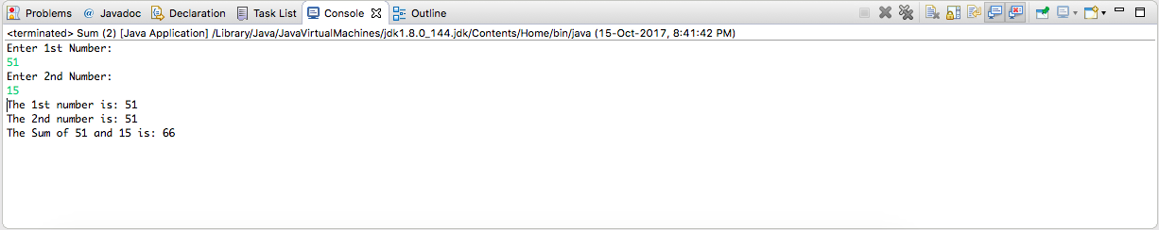

1. Write a program to accepts two numbers from stdin and find all the odd as well as even numbers present in between them.

Source Code: -

package pig4; //creation of package

import java.util.\*; //importing the java.util to access the Scanner class

public class OddEven { //main class of the program

public static void main(String[] args) { //main method of the program

int start, end, loop; //declaration of variables

Scanner sc = new Scanner(System.in);   // creation of object of scanner class

System.out.println("Enter the start of range: ");    //printing statement on console

start = sc.nextInt(); //storing the input from the user to a variable

System.out.println("Enter the end of range: ");    //printing statement on console

end = sc.nextInt(); //storing the input from the user to a variable

System.out.println("Even numbers between "+start+ " and "+end+" are: ");   //printing statement on console

for(loop = start; loop < end; loop++)    //for loop

{

if(loop % 2 == 0) { //condition to check even numbers

System.out.println(loop); //printing even values on console

}

}

System.out.println("Odd numbers between "+start+ " and "+end+" are: ");   //printing statement on console

for(loop = start; loop < end; loop++)    //for loop

{

if(loop % 2 != 0) { //condition to check odd numbers

System.out.println(loop); //printing odd values on console

}

}

sc.close();   //closing the scanner method

}

}

Output: -

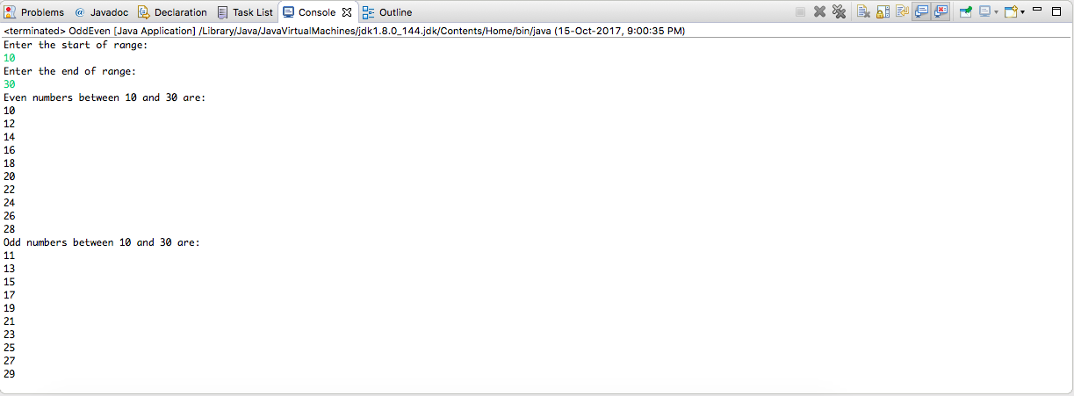

1. Joe is scared to go to school. When her dad asked the reason, joe said she is unable to

complete the task given by her teacher. The task was to find the “first 10 multiples” of the number entered from stdin . Eg:

Input: 3

O/p:

3 x 1 = 3

3 x 2 = 6

.........

.........

3 x 10 = 30

Help Joe in completing the task!

Source Code: -

package pig5; //creation of package

import java.util.\*; //importing java.util to access the Scanner class

public class MulTable { //creation of main class of the program

public static void main(String[] args) { //main method of the program

int num1, i;

Scanner sc = new Scanner(System.in);   //creating object of scanner class

System.out.println("Enter a number: "); //printing statement on console

num1 = sc.nextInt(); //taking input from user and storing it in num1 variable

for(i=1; i<=10;i++) { //for loop for multiplication

System.out.println(num1+ " x " +i+ " = " +(num1 \* i) );   //printing the table on console

}

sc.close(); //closing of scanner class

}

}

Output: -

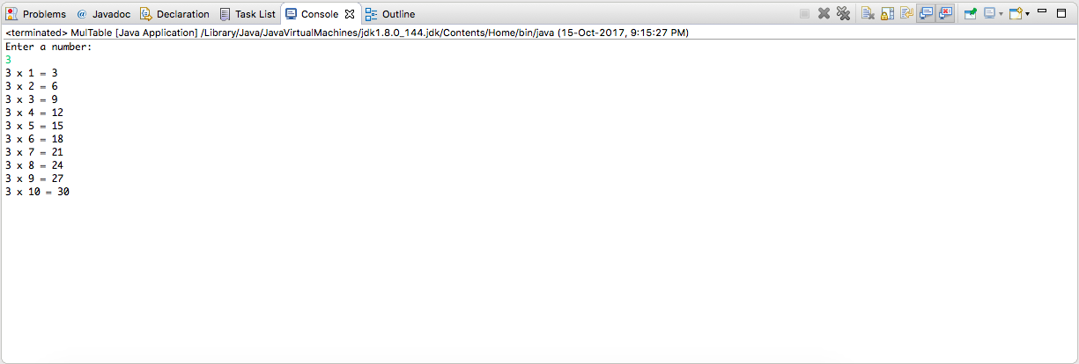

1. Write a program consisting method sum() and demonstrate the concept of method

overloading using this method.

Source Code: -

class Add { //creation on class Add to perform method overloading

public int sum (int num1, int num2) { //creation of sum method and passing two variables of integer type

int sum = num1 + num2; //declaration of variable and performing addition

return sum; //returning the value of sum

}

public int sum (int num1, int num2, int num3) {     //creation of sum method and passing three variables of integer type

int sum = num1 + num2 + num3; //declaration of variable and performing addition

return sum; //returning the value of sum

}

public double sum(double num1, double num2) {  //creation of sum method and passing two variables of double type

double sum = num1  + num2; //declaration of variable and performing addition

return sum; //returning the value of sum

}

}

public class MethodOverloadDemo { //main class of the program

public static void main(String[] args) { //main method of the program

double num4 = 12.5, num5 = 24.5;    //declaration of variables

int num1 = 12, num2 = 24, num3 = 36;    //declaration of variables

Add a =  new Add(); //creation of obejct of class Add

System.out.println("The sum is: "+a.sum(num1, num2));   //calling of method and displaying the output on console

System.out.println("The sum is: "+a.sum(num1, num2, num3));   //calling of method and displaying the output on console

System.out.println("The sum is: "+a.sum(num4, num5));   //calling of method and displaying the output on console

}

}

Output: -

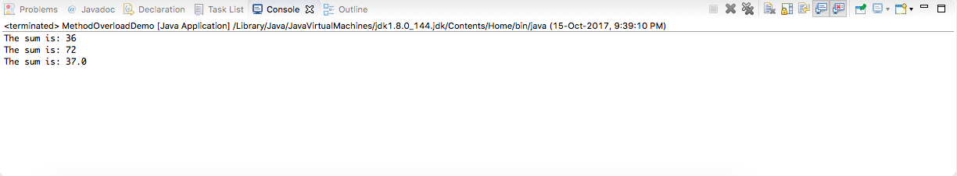

1. Can you overload a method with same return type.? Explain your answer with proper logic.

Ans: - Method Overloading is a feature that allows a class to have more than one method having the same name, if their argument lists are different.

Yes, we can overload a method with the same return type, but the values passed to that method should be different. i.e.,

class Add {

public int sum(int a, int b){

int sum = a + b;

return sum;

}

public int sum(int a, int b, int c){

int sum = a + b + c;

return sum;

}

}

public class Demo {

public static void main(String[] args) {

int num1 = 12, num2 = 24, num3 = 36;

Add a =  new Add();

System.out.println("The sum is: "+a.sum(num1, num2));

System.out.println("The sum is: "+a.sum(num1, num2, num3));

}

}

This is allowed. But if we have same return type and same parameters passed to the method it will give u an error, as the compiler will not be able to identify which method is being called in this kind of scenario.

Eg., This is will give an error

class Add {

public int sum(int a, int b){

int sum = a + b;

return sum;

}

public int sum(int a, int b){

int sum = a + b + c;

return sum;

}

}

public class Demo {

public static void main(String[] args) {

int num1 = 12, num2 = 24, num3 = 36;

Add a =  new Add();

System.out.println("The sum is: "+a.sum(num1, num2));

System.out.println("The sum is: "+a.sum(num1, num2));

}

}

Even if it has same return type and the parameters of different types are passed to it will still give you an error.

1. Write a program in java using Arrays, that sorts the element in descending order.

Source Code: -

package pig8; //creation of package

public class SortDemo { //main class of the program

public static void main(String[] args) { //main method of the  program

int arr[] = {2, 30, 21, 3, 55, 1, 10, 24};   //decalration of array and passing values into array

int i, j, temp;      //declaration of variable

for (i = 0; i < 8; i++)       //for loop

        {

            for (j = i + 1; j < 8; j++)

            {

                if (arr[i] < arr[j])    //checks if value is 1st value is smaller than second

                {

                /\*interchange the places\*/

                    temp = arr[i];

                    arr[i] = arr[j];

                    arr[j] = temp;

                }

            }

        }

        System.out.print("Decending Order:");   //displaying the message on console

        for (i = 0; i < 8; i++)

        {

            System.out.print(arr[i] + ","); //displaying the value on console

        }

}

}

Output: -

